CL-2005: Database Systems
Lab #11: Connection of C# Application Forms with SQL Server

Objective:
To make the windows application forms in C# and connect them to SQL Server.
Scope:
The student shall know the following:
  - SQL Commands. • C# Programming
  - Hands-on experience with the above-mentioned concepts.

Discussion:
We have studied the SQL commands in detail and C# programming, now we will make a form in visual studio using C# and then connect it with SQL Server which is our database.

Creation of Form in Visual Studio:
Open visual studio 2019, the screen is shown below will appear.

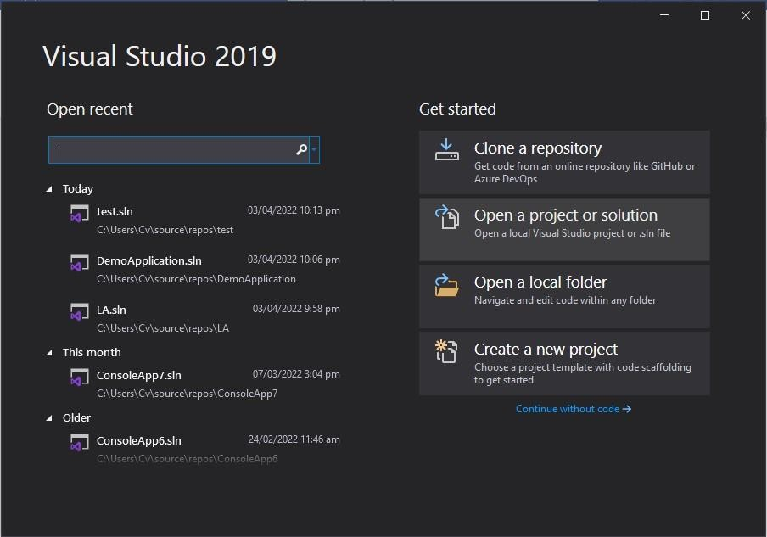

Click on the Create a new project. After clicking on that write in the search box Windows Forms App as shown on the screen below.

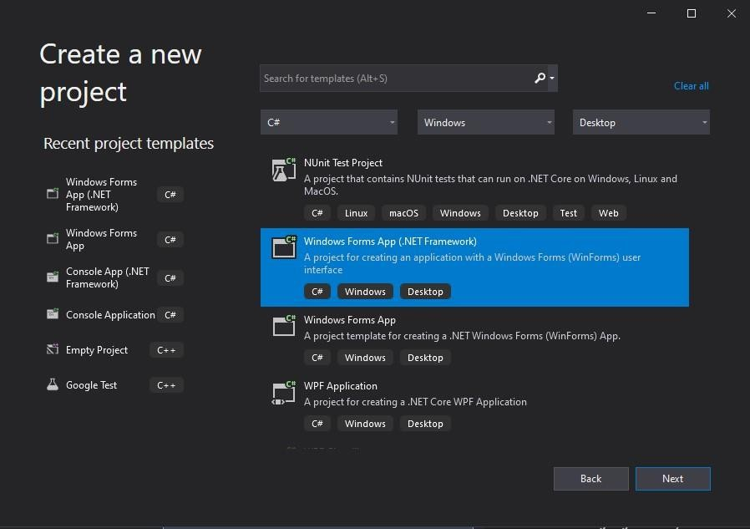

Choose the highlighted option and click on the Next button. The screen shown below will appear. Write the name of the form and location and then click on the Create button.
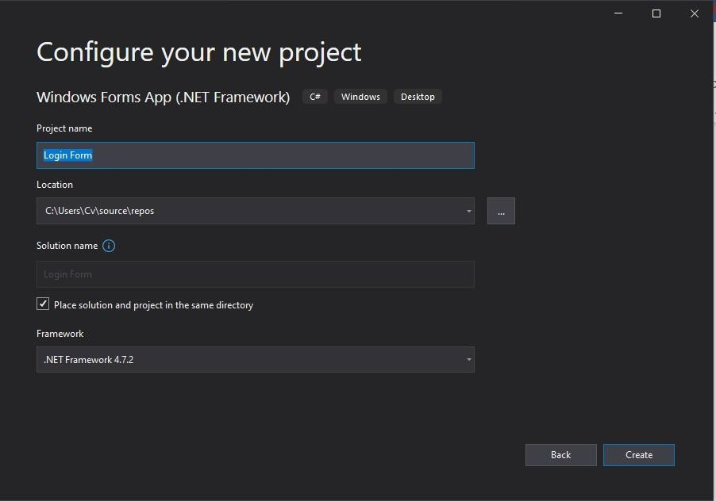
Your blank form is created successfully. You will see the screen as shown below.

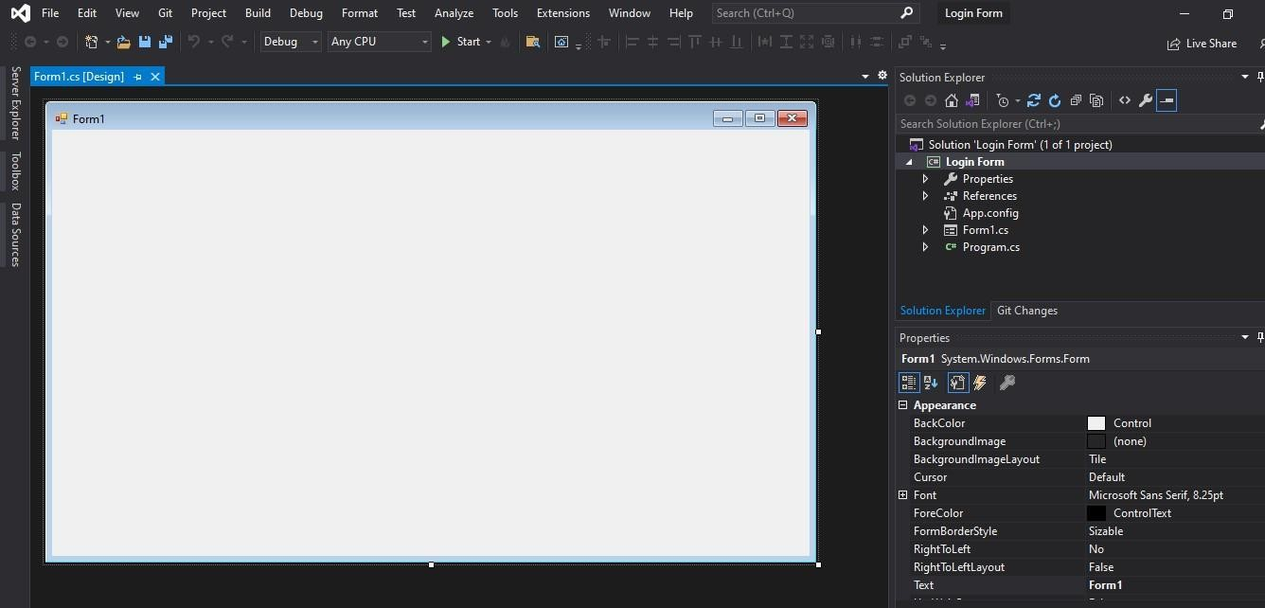

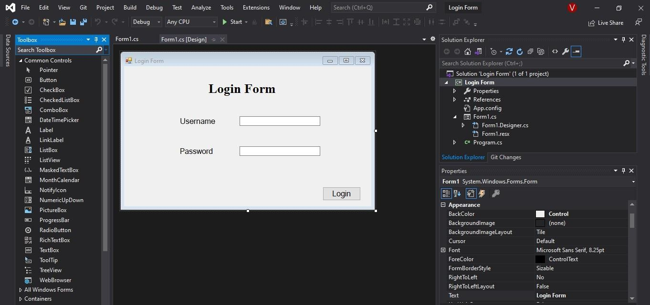
Now you have to create the login form for this insert labels, text boxes, buttons, etc. according to your requirement in the black form. You can insert it from the option on the left of the screen Toolbox.
The login form is successfully created by just drag and dropping the required controls. The color, font, and other properties of the form can be changed through the property panel present in the right corner of the visual studio.
Now the 2nd task is to create the database for this form using an SQL server.

Creation of Database in SQL Server:
Open the Microsoft SQL Server Management Studio and click on the connect button. After clicking on the connect button all the objects will appear on the left of the SQL server screen.
I have created the database named “Facebook Db” as shown in the screen below.

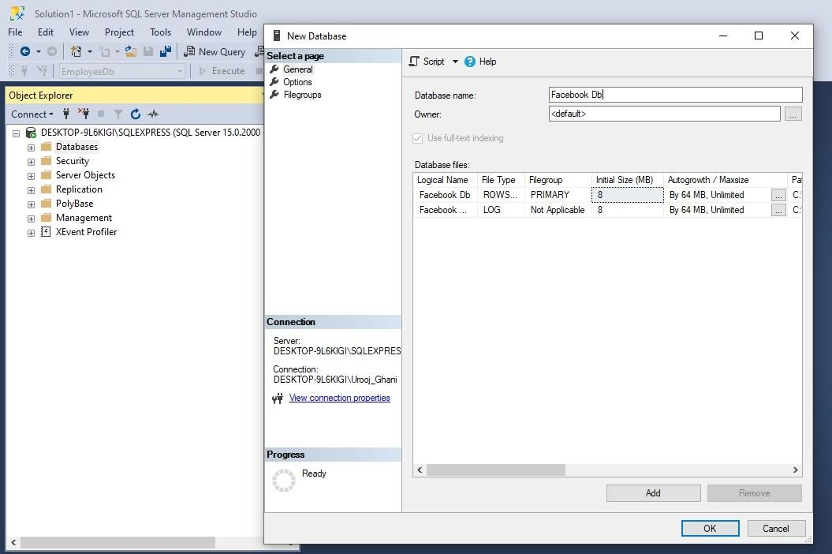
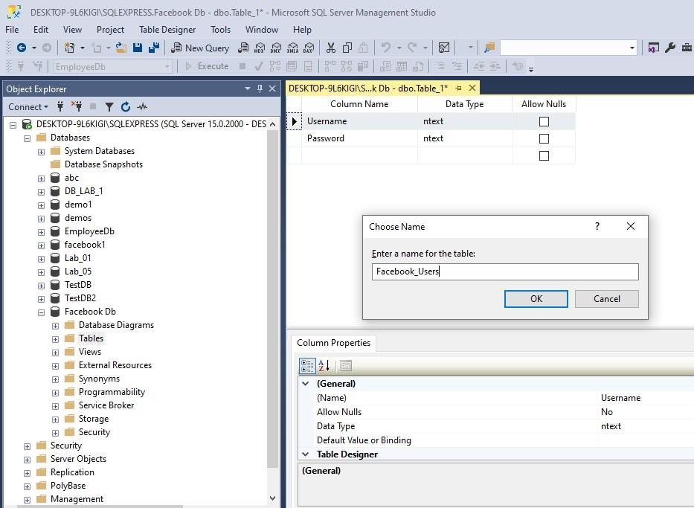
Click on the OK button. Now you can see the database in the left navigation pane objects. Now create a table with two columns because the form has two columns: username and password. Save the table as Facebook_Users.

Now you can check the table in the navigation pane. Right-click on the table Facebook_Users and select the top 1000 records option you can see the two columns with no data because we have not inserted any record.
Now we have created the C# Form and Database in SQL Server. Now we have to connect the form with the SQL server which means that when someone inserts the data in the login form that must be inserted in the SQL server table.

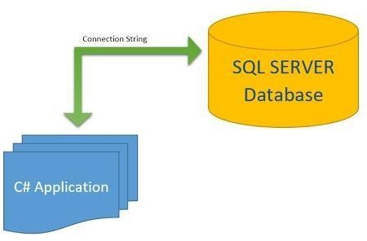
Connection of C# Form with SQL Server:

Open the visual studio and at the top of the option, there is the option Tools click on that and then click on Connect to Database. Now the screen shown below will appear.
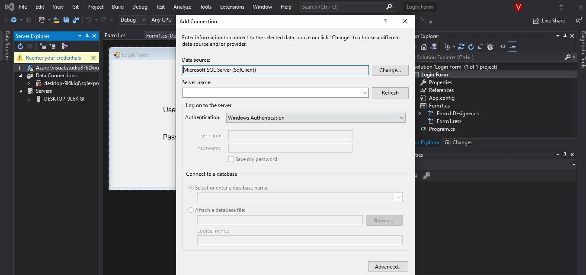
Now you have to enter the server’s name. For this open the SQL server and at the top of the SQL Server right click on the highlighted option and click on the connect.

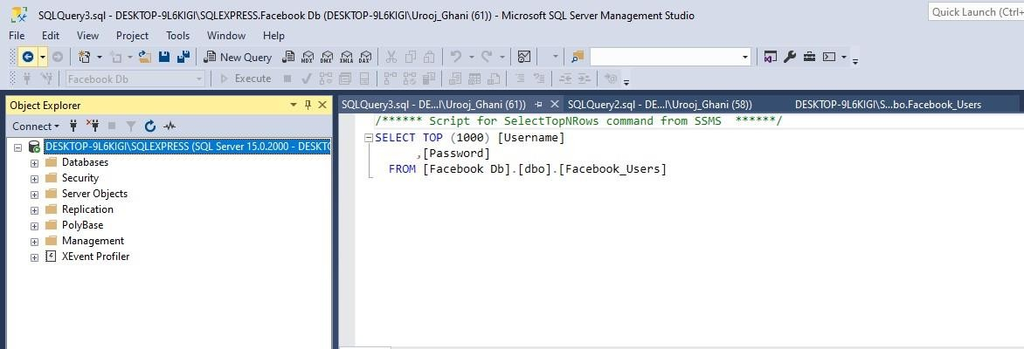
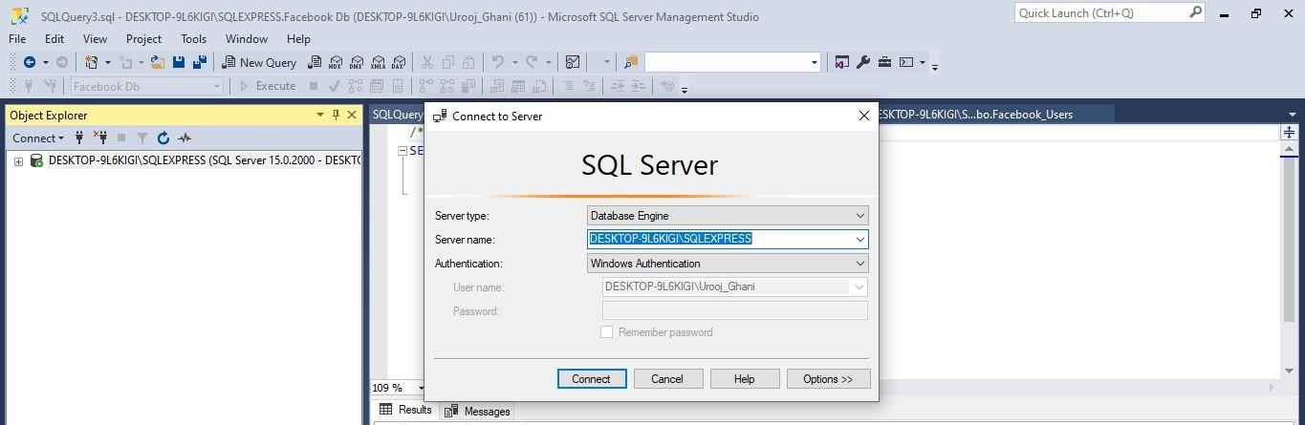

From this screen copy the server’s name and insert it into the visual studio server name. When you insert the server’s name then a radio button selects or enters a database name that will be enabled as shown below. Choose the name of the database to which you want to connect. My database name was Facebook Db, so I choose it.
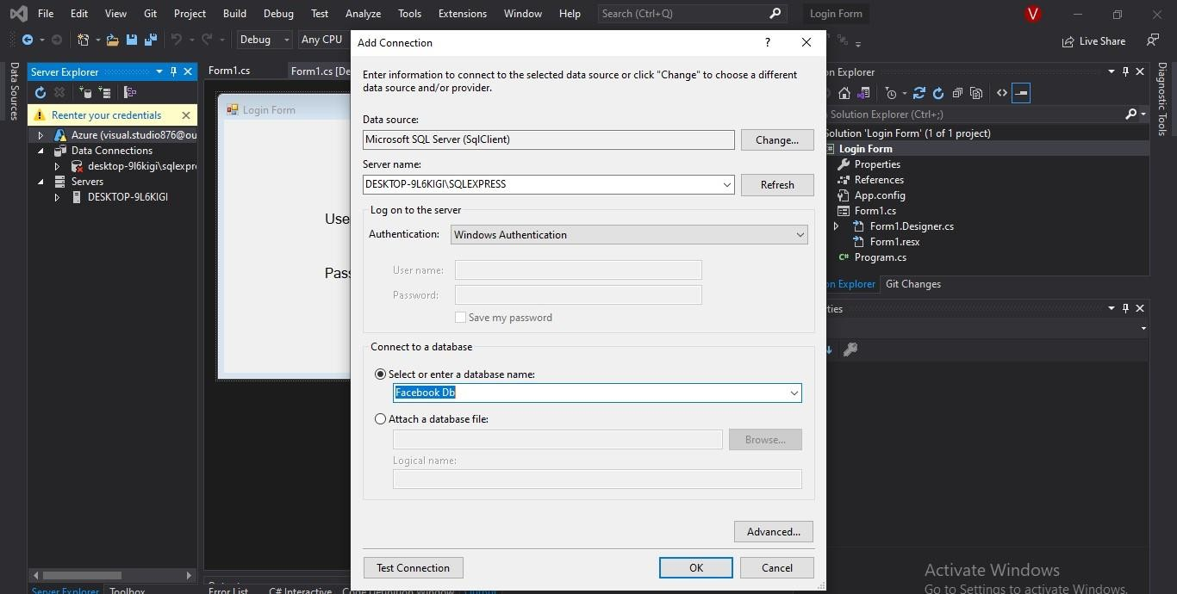

Click on the OK button. Now in the left panel of the visual studio under Server Explorer, in database connections, your server has been loaded as shown below. Now you can check the table by clicking on the server name and table.

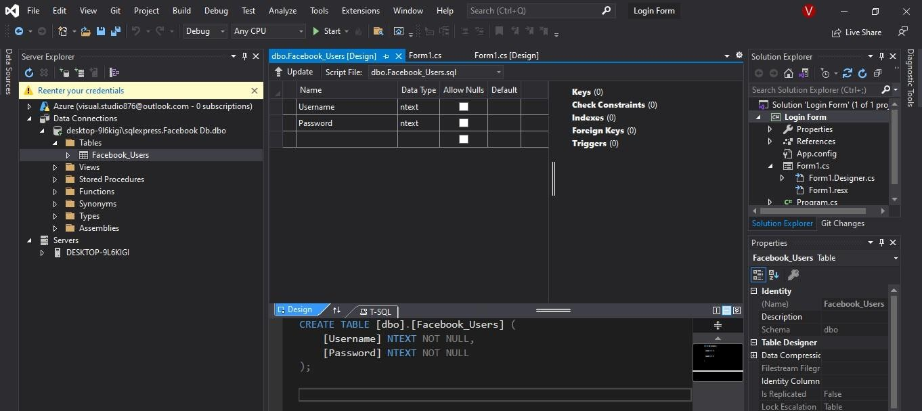

The SQL Server is successfully connected to the C# Application Form. Now we have to add an action listener in the button login, which means that when the user enters the data, the data must be inserted into the table. For this open the form design and double click on the login button, it will move you to the code section and write the code given below. Add the library at the top of the code “using System.Data.SqlClient;”. If you do not add it, then your code will give errors.
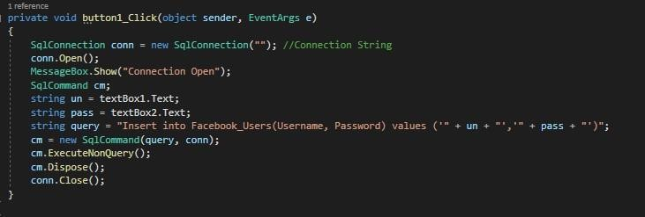
In the insert query, the Facebook_Users is the name of the table which we have created. You can write a query according to your table name and attributes. Here you can the Connection String in the comment. You have to write the connection string between the quotation marks. You can get it by clicking on the Server name properties of the server will appear at the right bottom of the Visual Studio as shown below.

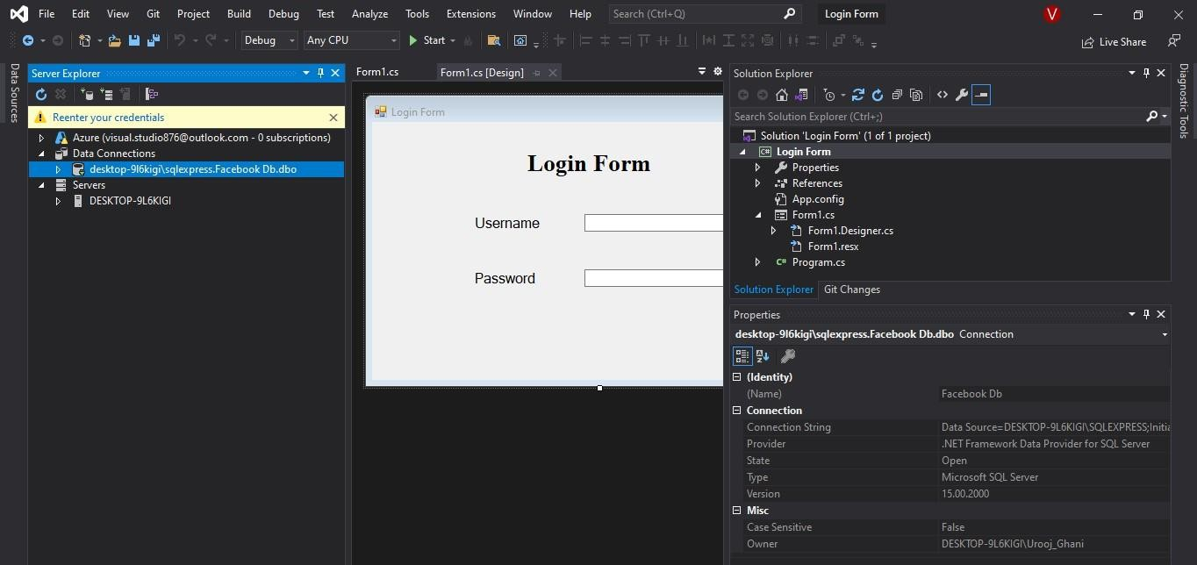

Copy the Connection String and paste it into the code.
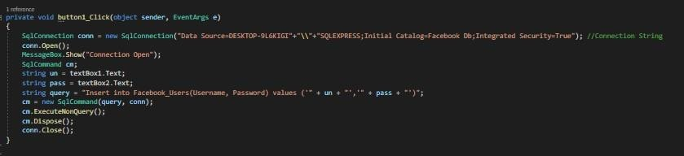
Run the code by clicking on the Start at the top of the visual studio. When you enter the data in the form, click on the ok and close the login form that data will go into the SQL server database.
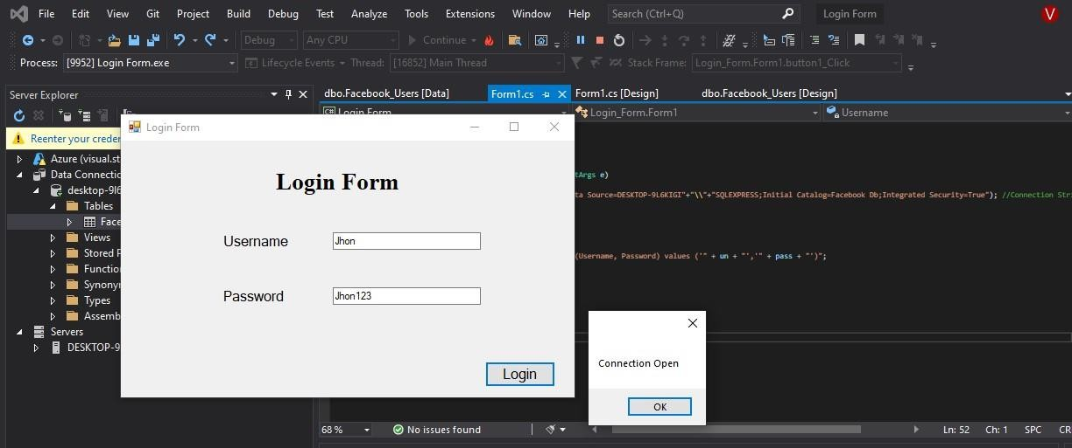

Now check the SQL Server table the data will be inserted, and the table present in Visual studio. Right-click on the table in the visual studio server explorer and click on show table data the data will be shown in the table.

Visual Studio Table Data:
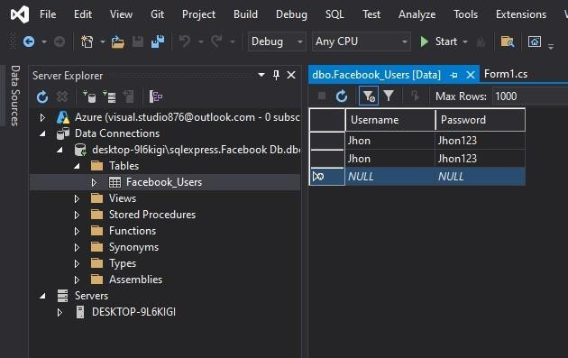

SQL Server Table Data:
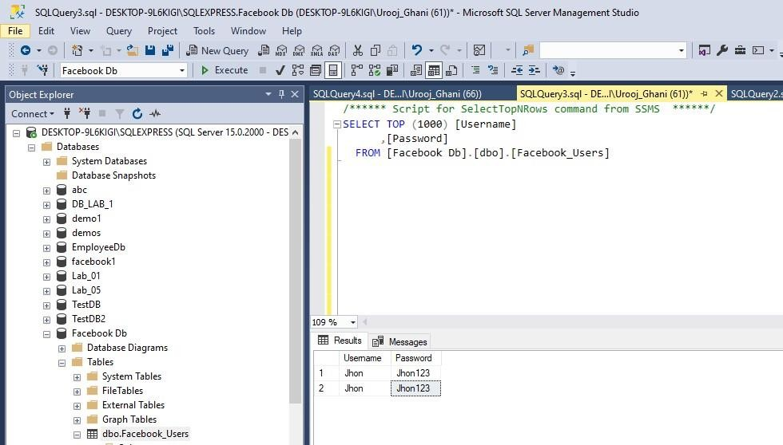

Tada! Your C# Application form is connected successfully with SQL Server Database

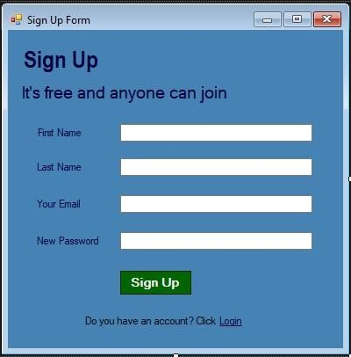
Task:

Create the signup form and add functionalities in the button sign up. When the user clicks on the sign up the data should be inserted into the database. And when the user clicks on the login link then the login screen appears.
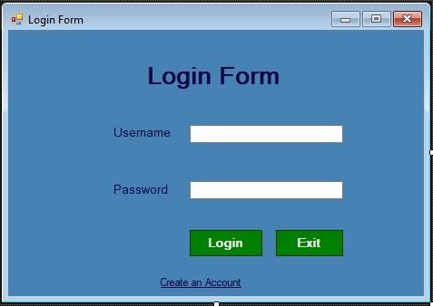

Only those users can log in whose data is present in the database for this you have to match the login data with the data of the registered users, if the data matches, then the dialogue box appears that says, “Login Successfully” and if does not match then it says, “Invalid Information”. When the user clicks on the Exit button the screen should exit. When the user clicks on the create an account the Sign-Up form should appear.

